PHYS1110D – Engineering Physics: Mechanics and Thermodynamics

Week 10: A Systematic Treatment on Rotations and Rigid Body

**TAKE-HOME MESSAGE:**

* Motion of a rigid body can be thought as the *superposition of motion of any fixed point on the rigid body (center of rotation) and rotation around it*. This point is usually chosen at the *center of mass*.
* Velocity of points on a rigid body
$$v_{a}=v_{CR}+ω×R_{a}, R_{a}=r_{a}-r_{CR}$$

* Acceleration of points on a rigid body
$$a_{a}=a_{CR}+\dot{ω}×R_{a}+ω×\left(ω×R_{a}\right)$$

* Kinetic energy of a rigid body = CM kinetic energy + Rotational kinetic energy
$$\text{K.E}=\frac{1}{2}Mv_{CM}^{2}+{\text{K.E}}_{\text{rot}}$$

* Linear momentum of a rigid body = CM linear momentum
$$p=Mv_{CM}$$

* Angular momentum of anything = CM angular momentum + Angular momentum around the CM

$$L=L_{CM}+L_{\text{rot}}$$

**Topic 1 – The Kinetic Quantities for Rotating Rigid Body**

To study rigid body rotation, a good choice of the coordinate system is crucial. Under most situations, people use 2 sets of coordinate axes:

* The usual *static* system $xyz$ where we live;
* The *moving* system $XYZ$ with its origin *fixed* at some point (let’s call it the *center of rotation[1]* (CR)) on the rigid body. In this system, the rigid body is *purely rotating with no translational motion* (why?).

 

*Example: Spinning Angular Speed = 10 $×$ Orbital Angular Speed*

The CR *can be anywhere in the rigid body*, but the convenient choice depends on the problem. The **spinning angular velocity** is the *same* for all choices of CR *(please think about it)*.

The most common choice of the CR is the center of mass (CM) of the rigid body.

As an example, consider a spinning square, whose CM is also rotating around the origin of the $xyz$ system. For an arbitrarily chosen CR, the path of this CR (red dashed curve) can be complicated (left); when CR is chosen at CM, the path is simply a circle around the $xyz$ origin (right).

However, in *both* cases, the motion of the square in the $XYZ$ system is *pure* rotation. The only difference is the position of the rotation axis.

Assume that the trajectory of CR in the $xyz$ system is given by $r_{CR}\left(t\right)$, and the rotation angle around the CR in the moving system is $γ\left(t\right)$. Here we consider only the simple case in which the rotation axis does not change its direction. Using the two sets of coordinate systems, the velocity on any point $a$ of the rigid body can be written as

$$\begin{aligned}v_{a}\left(t\right)=v_{CR}\left(t\right)+ω\left(t\right)×R_{a}\left(t\right)\#\left(1\right)\end{aligned}$$

i.e. the superposition of the velocity of CR and the velocity of $a$*relative to the CR (in the $XYZ$ system)*.

*Proof using the rotation matrix* (this part is not necessary for understanding other parts in this tutorial):

Since the rotation axis does not change its direction, we can use the rotation matrix to express the position of $a$ at any time $t$: the position $R_{a}$ of $a$ on the rigid body *relative to the CR* is

$$R_{a}\left(t\right)=r_{a}\left(t\right)-r_{CR}\left(t\right)=R\left(γ\left(t\right)\right)R_{a}\left(0\right)$$

Here we measure the rotation angle from the time $t=0$, and thus $γ\left(0\right)=0$. In other words, the position of this point is

$$r_{a}\left(t\right)=r_{CR}\left(t\right)+R\left(γ\left(t\right)\right)R_{a}\left(0\right)$$

The time derivative gives the velocity

$$v_{a}\left(t\right)=v_{CR}\left(t\right)+\frac{dR\left(γ\left(t\right)\right)}{dt}R_{a}\left(0\right)$$

But we know that the time derivative of the rotation matrix is related to the angular velocity vector. Recall that if $γ\left(0\right)=0$, then we have

$${\left[\frac{dR\left(γ\left(t\right)\right)}{dt}\right]}_{t=0}r\left(0\right)=ω\left(0\right)×r\left(0\right)$$

How can we generalize this result to any time $t$? Suppose that the time we are interested in is $t_{1}$, i.e. we want to find

$$v_{a}\left(t_{1}\right)=v_{CR}\left(t_{1}\right)+{\left[\frac{dR\left(γ\left(t\right)\right)}{dt}\right]}_{t=t_{1}}R_{a}\left(0\right)$$

This can be done by the common trick of decompose the rotation into 2 steps:

$$R\left(γ\left(t\right)\right)=R\left(γ\left(t\right)-γ\left(t_{1}\right)\right)R\left(γ\left(t_{1}\right)\right)=R\left(γ\left(t_{1}\right)\right)R\left(γ\left(t\right)-γ\left(t_{1}\right)\right)$$

The order of the two rotations can be exchanged, because they are around the same axis. Keep in mind that $t_{1}$ is a *constant*. Now take the time derivative:

$${\left[\frac{dR\left(γ\left(t\right)\right)}{dt}\right]}_{t=t_{1}}R_{a}\left(0\right)={\left[\frac{dR\left(γ\left(t\right)-γ\left(t_{1}\right)\right)}{dt}\right]}_{t=t_{1}}R\left(γ\left(t_{1}\right)\right)R_{a}\left(0\right)$$

Since ${\left[γ\left(t\right)-γ\left(t_{1}\right)\right]}_{t=t_{1}}=0$, we can relate the right-hand side to the angular velocity vector:

$${\left[\frac{dR\left(γ\left(t\right)-γ\left(t_{1}\right)\right)}{dt}\right]}_{t=t_{1}}R\left(γ\left(t_{1}\right)\right)R_{a}\left(0\right)=ω\left(t_{1}\right)×\left(R\left(γ\left(t_{1}\right)\right)R_{a}\left(0\right)\right)=ω\left(t_{1}\right)×R_{a}\left(t_{1}\right)$$

Therefore, we proved something that you can easily feel to be correct:

$$v_{a}\left(t_{1}\right)=v_{CR}\left(t_{1}\right)+ω\left(t_{1}\right)×R_{a}\left(t_{1}\right)$$

i.e. the velocity of any point on a rigid body can be written as the sum of the CR velocity and the velocity of rotation around the axis through CR. Since this equation is true for any $t_{1}$, we can omit the subscript and write

$$v_{a}\left(t\right)=v_{CR}\left(t\right)+ω\left(t\right)×R_{a}\left(t\right)$$

This is exactly eq. (1).

To get the acceleration, we only need to differentiate again:

$$a_{a}\left(t\right)=a_{CR}\left(t\right)+\dot{ω}\left(t\right)×R_{a}\left(t\right)+ω\left(t\right)×{\dot{R}}_{a}\left(t\right)$$

But you already know what ${\dot{R}}_{a}\left(t\right)$ is:

$${\dot{R}}_{a}\left(t\right)=ω\left(t\right)×R_{a}\left(t\right)$$

Therefore, the final expression for the acceleration is

$$\begin{aligned}a_{a}\left(t\right)=a_{CR}\left(t\right)+\dot{ω}\left(t\right)×R_{a}\left(t\right)+ω\left(t\right)×\left(ω\left(t\right)×R_{a}\left(t\right)\right)\#\left(2\right)\end{aligned}$$

Equations (1) and (2) have a much wider applicability than those you have memorized (incompletely) so far, and we recommend adding them to your cheat sheet for Quiz 2.

*Remark:*

$ω\left(t\right)×\left(ω\left(t\right)×R_{a}\left(t\right)\right)$ is the *vector form* of the **centripetal acceleration**.

*Example: Question 3, Assignment 6*

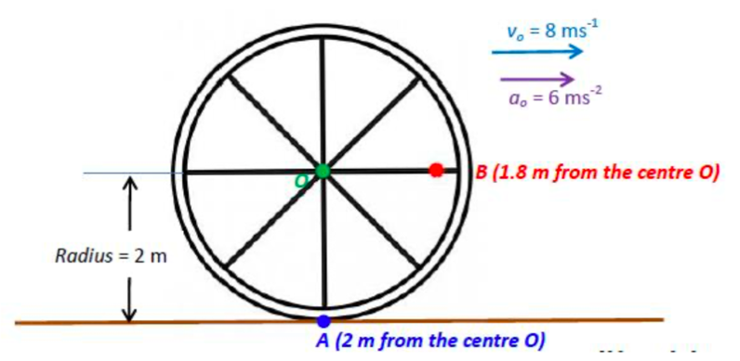

**Solution 1:**

Let us choose the CR to be the center of the wheel. In this problem, $v_{CR}\left(0\right)=8e_{x} \text{m/s}, a_{CR}\left(0\right)=6e_{x} \text{m/}{\text{s}}^{\text{2}}$. The wheel radius is $r_{0}=2 \text{m}$. Because the wheel is purely rolling, the angular speed and the angular acceleration of the wheel are related to $v_{CR}, a_{CR}$ by

$$ω\left(0\right)=-\frac{v_{CR}}{r_{0}}e_{z}=-4e_{z} \text{rad/s}$$

$$\dot{ω}\left(0\right)=-\frac{a_{CR}}{r_{0}}e_{z}=-3e_{z} \text{rad/}{\text{s}}^{\text{2}}$$

Now we can apply equations (1) and (2) to find the quantities at $t=0$.

* Point A: $R_{A}\left(0\right)=\left(0, -2, 0\right) \text{m}$
$$v_{A}\left(0\right)=v_{CR}\left(0\right)+ω\left(0\right)×R_{A}\left(0\right)=\left(8, 0, 0\right)+\left(0, 0, 4\right)×\left(0, -2, 0\right)=\left(0, 0, 0\right) \text{m/s}$$

$$\begin{aligned}a_{A}\left(0\right)&=a_{CR}\left(t\right)+\dot{ω}\left(t\right)×R_{A}\left(t\right)+ω\left(t\right)×\left(ω\left(t\right)×R_{A}\left(t\right)\right) \\ &=\left(6, 0, 0\right)+\left(0, 0, -3\right)×\left(0, -2, 0\right)+\left(0, 0, -4\right)×\left[\left(0, 0, -4\right)×\left(0, -2, 0\right)\right] \\ &=\left(0, 32, 0\right) \text{m/}{\text{s}}^{\text{2}}\end{aligned}$$

* Point B: $R_{B}\left(0\right)=\left(1.8, 0, 0\right) \text{m}$

$$v_{B}\left(0\right)=v_{CR}\left(0\right)+ω\left(0\right)×R_{B}\left(0\right)=\left(8, 0, 0\right)+\left(0, 0, -4\right)×\left(1.8, 0, 0\right)=\left(8, -7.2, 0\right) \text{m/s}$$

$$\begin{aligned}a_{B}\left(0\right)&=a_{CR}\left(t\right)+\dot{ω}\left(t\right)×R_{B}\left(t\right)+ω\left(t\right)×\left(ω\left(t\right)×R_{B}\left(t\right)\right) \\ &=\left(6, 0, 0\right)+\left(0, 0, -3\right)×\left(1.8, 0, 0\right)+\left(0, 0, -4\right)×\left[\left(0, 0, -4\right)×\left(1.8, 0, 0\right)\right] \\ &=\left(-22.8, -5.4, 0\right) \text{m/}{\text{s}}^{\text{2}}\end{aligned}$$

**Solution 2:**

You can also express $r_{A, B}\left(t\right)$ in terms of its Cartesian components, and directly do the differentiations to find the velocity and the acceleration. As an example, for point A:



First, the position of the center of mass is at

$$x_{CM}\left(t\right)=v_{0}t+\frac{1}{2}a_{0}t^{2}$$

By the pure rolling condition, the rotation angle is

$$θ\left(t\right)=\frac{x_{CM}\left(t\right)}{r_{0}}=ω_{0}t+\frac{1}{2}α_{0}t^{2} \left(ω_{0}=\frac{v_{0}}{r_{0}}, α_{0}=\frac{a_{0}}{r_{0}}\right)$$

Now we can write down:

* Position
$$x\left(t\right)=x_{CM}\left(t\right)-r_{0}\sin{θ\left(t\right)}, y\left(t\right)=r_{0}-r_{0}\cos{θ\left(t\right)}$$

* Velocity
$$\begin{aligned}v_{x}\left(t\right)&={\dot{x}}_{CM}\left(t\right)-r_{0}\dot{θ}\left(t\right)\cos{θ\left(t\right)}&=&\left(ω_{0}r_{0}+a_{0}t\right)-r_{0}\left(ω_{0}+α_{0}t\right)\cos{θ\left(t\right)} \\ v_{y}\left(t\right)&=r_{0}\dot{θ}\left(t\right)\sin{θ\left(t\right)}&=&r_{0}\left(ω_{0}+α_{0}t\right)\sin{θ\left(t\right)}\end{aligned}$$

* Acceleration

$$\begin{aligned}a_{x}\left(t\right)&=a_{0}+r_{0}ω_{0}\dot{θ}\left(t\right)\sin{θ\left(t\right)}-r_{0}α_{0}\cos{θ\left(t\right)} \\ &=a_{0}+v_{0}\left(ω_{0}+α_{0}t\right)\sin{θ\left(t\right)}-a_{0}\cos{θ\left(t\right)} \\ a_{y}\left(t\right)&=r_{0}ω_{0}\dot{θ}\left(t\right)\cos{θ\left(t\right)}+r_{0}α_{0}\sin{θ\left(t\right)} \\ &=r_{0}ω_{0}\left(ω_{0}+α_{0}t\right)\cos{θ\left(t\right)}+a_{0}\sin{θ\left(t\right)}\end{aligned}$$

In the problem,

$$r_{0}=2 \text{m}, ω_{0}=4 \text{rad/s} \left(v_{0}=8 \text{m/s}\right), α=3 \text{rad/s} \left(a_{0}=6 \text{m/}{\text{s}}^{\text{2}}\right)$$

The question asks for $v\left(0\right)$ and $a\left(0\right)$. Notice that $\sin{θ\left(0\right)}=0,\cos{θ\left(0\right)}=1$. We obtain the velocity:

$$v\left(0\right)=\left(ω_{0}r_{0}-r_{0}ω_{0}, 0\right)=\left(0, 0\right)$$

The acceleration is

$$a\left(0\right)=\left(a_{0}-r_{0}α, r_{0}ω_{0}^{2}\right)=\left(0, ω_{0}r^{2}\right)=\left(0, 32\right) \text{m/}{\text{s}}^{\text{2}}$$

*Remark:*

The trajectory of the point A is called a **cycloid**, a curve famous for its various interesting properties. Visit Wikipedia to learn about them.

*Exercise 1 – Instant Center of Rotation in Rolling Problems*



A round uniform plate (radius $r_{0}$) in the $xy$-plane is rolling on a flat surface. At $t=0$, the plate center is on the $y$ axis, at $\left(0, r_{0}\right) \left(r_{0}>0\right)$. The center of mass of the plate has a constant velocity $v_{CM}=\left(ω_{0}r_{0}, 0\right)$.

We make a color point P on the plate and watch its trajectory in space. Let the position, the velocity and the acceleration of the point be $r\left(t\right), v\left(t\right), a\left(t\right)$. Initially, the color point is at $r\left(0\right)=\left(r_{0}-b\right)e_{y} \left(0<b<r_{0}\right)$.

1. Let the position of the color point *relative* to the contact point $\left(ω_{0}r_{0}t, 0\right)$ be $R\left(t\right)$. What is the value of $v\left(t\right)∙R\left(t\right)$?
2. Calculate $ω×R\left(t\right)$. Here we promote all 2D vectors to 3D, and $ω=\left(0, 0, -ω_{0}\right)$.

**Solution:**

1. The position of the color point is at

$$r\left(t\right)=\left(ω_{0}r_{0}t-b\sin{ω_{0}t}, r_{0}-b\cos{ω_{0}t}\right)$$

And the relative position is

$$R\left(t\right)=r\left(t\right)-\left(ω_{0}r_{0}t, 0\right)=\left(-b\sin{ω_{0}t}, r_{0}-b\cos{ω_{0}t}\right)$$

Then

$$\begin{aligned}v\left(t\right)∙R\left(t\right)=&\left(ω_{0}r_{0}-ω_{0}b\cos{ω_{0}t}\right)\left(-b\sin{ω_{0}t}\right) \\ &+ ω_{0}b\sin{ω_{0}t}\left(r_{0}-b\cos{ω_{0}t}\right)=0\end{aligned}$$

1. By direct calculation

$$\begin{aligned}ω×R\left(t\right)&=\det\left(\begin{matrix}e_{x} & e_{y} & e_{z} \\ 0 & 0 & -ω_{0} \\ -b\sin{ω_{0}t} & r_{0}-b\cos{ω_{0}t} & 0\end{matrix}\right) \\ &=\left(ω_{0}r_{0}-ω_{0}b\cos{ω_{0}t},ω_{0}b\sin{ω_{0}t}, 0\right) \end{aligned}$$

You should recognize that this is equal to $v\left(t\right)$. Now you have confirmed that *the plate can be regarded as rotating around the contact point at every instant*. The corresponding angular speed is also $ω$. Because of this reason, the contact point is called the **instant center of rotation** of the rolling plate.

*Remark:*

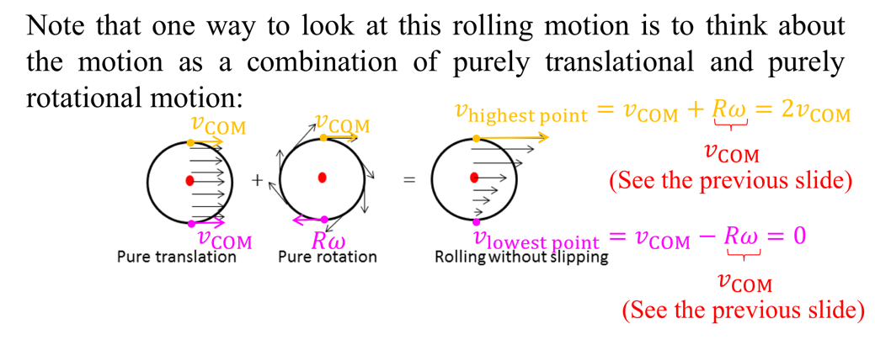

We remind you that the plate is not *really* rotating around the contact point, and you should *not* use this to calculate the *acceleration* of points on the plate. This is because the picture of instant rotation only gives the correct motion up to the *first order* of time (in the Taylor series of the position function), but the acceleration is a *second-order* derivative.

**Topic 2 – The Rotational Kinetic Energy in Various Situations**

* *Separation of the Rotational Kinetic Energy and the Center-of-Mass Kinetic Energy*

Consider a rigid body moving in the space with CM velocity $v_{CM}$. The whole body is rotating around an axis through the CM with angular speed $ω$. For convenience, we choose the $z$-axis to be parallel to the angular velocity, so that $ω=\left(0, 0, ω_{z}\right)$.

To do the separation, we use the relation just proved (the CR is chosen to be the CM of the body):

$$v_{a}=v_{CM}+ω×R_{a}$$

Here $R_{a}=r_{a}-r_{CM}=\left(X_{a}, Y_{a}, Z_{a}\right)$ is the position of $a$ relative to the center of mass. With our choice of the coordinates,

$$ω×r=\det\left(\begin{matrix}e_{x} & e_{y} & e_{z} \\ 0 & 0 & ω_{z} \\ x & y & z\end{matrix}\right)=\left(-ω_{z}y, ω_{z}x, 0\right)$$

We obtain

$$\begin{aligned}\text{K.E.}&=\sum_{a}{\frac{1}{2}m_{a}v_{a}^{2}}=\sum_{a}{\frac{1}{2}m_{a}{\left(v_{CM}+ω×R_{a}\right)}^{2}} \\ &=\sum_{a}{\frac{1}{2}m_{a}\left(v_{CM}^{2}+2v_{CM}∙\left(ω×R_{a}\right)+{\left(ω×R_{a}\right)}^{2}\right)} \\ &=\frac{1}{2}\left(\sum_{a}{m_{a}}\right)v_{CM}^{2}+\frac{1}{2}∙2v_{CM}∙\left(ω×\sum_{a}{m_{a}R_{a}}\right)+\sum_{a}{\frac{1}{2}m_{a}ω_{z}^{2}\left(X_{a}^{2}+Y_{a}^{2}\right)}\end{aligned}$$

The first term is just the center-of-mass translational K.E:

$$\begin{aligned}{\text{K.E}}_{CM}=\frac{1}{2}\left(\sum_{a}{m_{a}}\right)v_{CM}^{2}=\frac{1}{2}Mv_{CM}^{2}\#\left(3\right)\end{aligned}$$

The second term *vanishes*, because (please prove this relation by yourself)

$$\sum_{a}{m_{a}R_{a}}=0$$

This shows why the separation is possible *only with respect to the center of mass*. The third term *motivates* the definition of $I_{CM}$: we want something that looks like $\frac{1}{2}mv^{2}$, say

$$\begin{aligned}{\text{K.E}}_{\text{rot}}=\frac{1}{2}I_{CM}ω_{z}^{2}\#\left(4\right)\end{aligned}$$

Therefore, we *define* the moment of inertia around the rotation axis through CM to be

$$I_{CM}=\sum_{a}{m_{a}\left(X_{a}^{2}+Y_{a}^{2}\right)}$$

The kinetic energy of a rigid body now separates into two terms:

$$\begin{aligned}\text{K.E}={\text{K.E}}_{CM}+{\text{K.E}}_{\text{rot}}\#\left(5\right)\end{aligned}$$

*Remark:*

You can think about the modifications we need to make if $ω$ is along the $x$ or $y$ direction. However, the real challenge is the general case when $ω$ is *not along any coordinate axis*. In this case, the moment of inertia will become a $3×3$**matrix** (or, using the more formal but accurate name, **tensor**), and the rotational K.E has the form

$${\text{K.E}}_{\text{rot}}=\sum_{i, j=1}^{3}{\frac{1}{2}I_{ij}ω_{i}ω_{j}}=\frac{1}{2}I_{ij}ω_{i}ω_{j} \left(\text{Using Einstein Summation Rule}\right)$$

Can you try finding out the matrix elements $I_{ij}$?

* *Rigid Body Rotating around A Fixed Axis: The Parallel-Axis Theorem*

In this case, the center of mass velocity can also be expressed by the angular velocity vector:

$$v_{CM}=ω×\left(-R_{CR}\right)=\left(ω_{z}Y_{CR}, -ω_{z}X_{CR}, 0\right)$$

Again, for convenience, we choose the rotation axis to be parallel to the $z$-axis. Here $R_{CR}$ is the position of the CR relative to the CM. Then the kinetic energy is

$$\begin{aligned}\text{K.E}\end{aligned}=\frac{1}{2}Mv_{CM}^{2}+{\text{K.E}}_{\text{rot}}=\frac{1}{2}Mω_{z}^{2}\left(Y_{CR}^{2}+X_{CR}^{2}\right)+\frac{1}{2}I_{CM}ω_{z}^{2}$$

Now, if we *define* the moment of inertia around this rotation axis to be

$$\begin{aligned}I=M\left(X_{CR}^{2}+Y_{CR}^{2}\right)+I_{CM}\#\left(6\right)\end{aligned}$$

Then the expression simplifies further:

$$\text{K.E}=\frac{1}{2}Iω_{z}^{2}$$

Notice that $X_{CR}^{2}+Y_{CR}^{2}$ is the *distance* between the CM and the rotation axis (because, by definition, the CR is on this axis, which is parallel to $z$-axis). Thus, eq. (6) is the **Parallel Axis Theorem**.

*Remark:*

Return to the rolling wheel problem. Its kinetic energy is given by

$$\text{K.E}=\frac{1}{2}Mv_{CM}^{2}+\frac{1}{2}I_{CM}ω^{2}=\frac{1}{2}M{\left(ωr_{0}\right)}^{2}+\frac{1}{2}I_{CM}ω^{2}=\frac{1}{2}\left(Mr_{0}^{2}+I_{CM}\right)ω^{2}$$

However, we have another way to get the same answer: since at any instant $t$, the wheel can be regarded as rotating around its lowest point with angular speed $ω$, we can use the moment of inertia with respect to the axis through this contact point. By the parallel axis theorem

$$I=I_{CM}+Mr_{0}^{2}$$

Then

$$\text{K.E}=\frac{1}{2}Iω^{2}=\frac{1}{2}\left(Mr_{0}+I_{CM}\right)ω^{2}$$

Now I hope that you have a better understanding of this table:

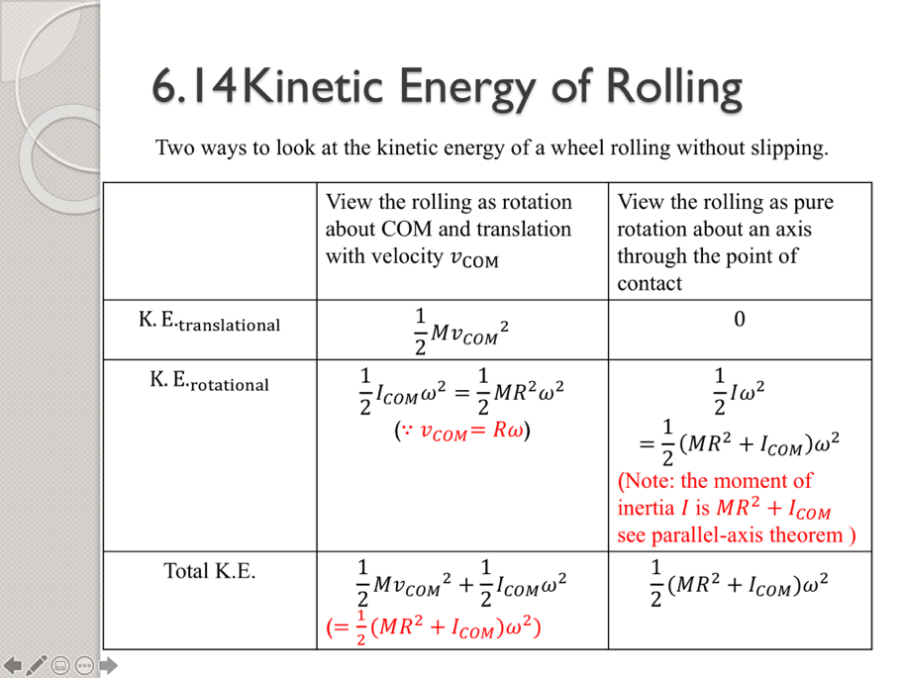

*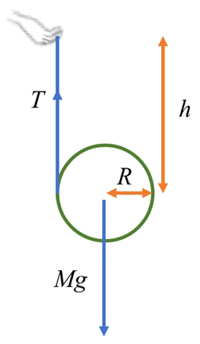Exercise 2: Rotational Kinetic Energy*

A yo-yo of mass $m$ and radius $R$ is released from hand. No sliding occurs between the yo-yo and the rope. Neglecting the mass of the rope:

1. Find the tension $T$ on the string (the moment of inertia of the yo-yo about the rotation axis is $\frac{1}{2}mR^{2}$).
2. Find the acceleration of the center of mass of the yo-yo.
3. Find the speed of the center of mass in terms of $h$ through which it has descended.

**Solution:**

Instead of drawing the free body diagram and get all the forces first, we start directly from the conservation of energy (we used the condition for pure rolling $v=ωR$)

$$E=\frac{1}{2}m{v\left(t\right)}^{2}+\frac{1}{2}I{ω\left(t\right)}^{2}-mgh\left(t\right)=\frac{3}{4}mv{\left(t\right)}^{2}-mgh\left(t\right)$$

(We have set the initial height of the yo-yo to correspond to zero potential energy.) Initially, the yo-yo has zero total energy. Therefore

$$0=\frac{3}{4}mv{\left(t\right)}^{2}-mgh\left(t\right)⟹v\left(t\right)=\sqrt{\frac{4gh\left(t\right)}{3}}$$

Taking the time derivative of the energy (note that the *chain rule* should be used here):

$$0=\frac{dE}{dt}=\frac{3}{2}mv\left(t\right)\dot{v}\left(t\right)-mgv\left(t\right)$$

Thus, we get the acceleration of the yo-yo:

$$\dot{v}\left(t\right)=\frac{2}{3}g \left(\text{Downwards}\right)$$

Finally, the tension in the rope can be found from

$$Mg-T=m\dot{v}\left(t\right)⟹T=\frac{1}{3}mg \left(\text{Upwards}\right)$$

*Exercise 3 – Parallel Axis Theorem*

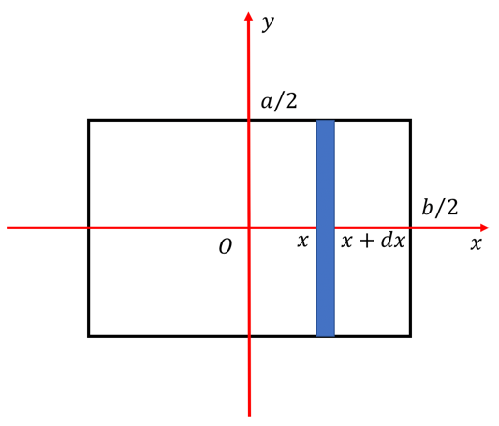The standard way of finding the moment of inertia is multi-variable integration, which you have not yet learned. However, with the help of the parallel axis theorem, you can already tackle some objects with simple shapes. Show that the moment of inertia of a uniform rectangle (edge length $a, b$) around the axis through its center and perpendicular to it is ${m\left(a^{2}+b^{2}\right)}/{12}$.

**Solution:**

Let the surface mass density be $σ=m/{ab}$. Then by the Parallel-axis Theorem (take the $z$-axis to be the rotation axis)

$$\begin{aligned}I&=\int_{-b/2}^{b/2}{\left(\frac{1}{12}dm a^{2}+dm x^{2}\right)}=\int_{-b/2}^{b/2}{\left(\frac{1}{12}σ\left(a dx\right)a^{2}+σ\left(a dx\right)x^{2}\right)} \\ &=\frac{ma}{b}\int_{-b/2}^{b/2}{dx\left(\frac{a^{2}}{12}+x^{2}\right)}=\frac{1}{12}m\left(a^{2}+b^{2}\right)\end{aligned}$$

**Topic 3 – Linear Momentum and Angular Momentum of A Rigid Body**

By choosing the CM as the origin of the $XYZ$ system (i.e. the CR), we can simplify the expressions of the linear and the angular momentum of a rigid body.

* *The linear momentum*

By definition, we obtain ( $R_{a}$ is the position *relative to the CM*)

$$\begin{aligned}p&=\sum_{a}{p_{a}}=\sum_{a}{m_{a}v_{a}}=\sum_{a}{m_{a}\left(v_{CM}+ω×R_{a}\right)} \\ &=\left(\sum_{a}{m_{a}}\right)v_{CM}+ω×\sum_{a}{m_{a}R_{a}}\end{aligned}$$

We meet the expression $\sum_{a}{m_{a}R_{a}}$ again, which is identically zero. Therefore

$$p=Mv_{CM}$$

i.e. *the linear momentum of a rigid body is equal to the linear momentum of the CM*.

* *The angular momentum*

Again, by definition

$$\begin{aligned}L&=\sum_{a}{L_{a}}=\sum_{a}{r_{a}×\left(m_{a}v_{a}\right)}=\sum_{a}{r_{a}×m_{a}\left(v_{CM}+{\dot{R}}_{a}\right)} \\ &=\left(\sum_{a}{m_{a}r_{a}}\right)×v_{CM}+\sum_{a}{r_{a}×m_{a}{\dot{R}}_{a}} \\ &=\left(Mr_{CM}\right)×v_{CM}++\sum_{a}{r_{a}×m_{a}{\dot{R}}_{a}} \\ &=L_{CM}+L_{\text{rot}}\end{aligned}$$

i.e. *the angular momentum is the sum of the CM angular momentum and the spinning angular momentum in the $XYZ$ system*.

Notice that we *did not use ${\dot{R}}_{a}=ω×R_{a}$* , thus this separation is *also valid for non-rigid bodies*.

*Example: Question 5, Assignment 6*

In the following figure, a small $m_{1}=$ 50g block slides down a frictionless surface through height $h$ = 20 cm and then sticks to a uniform rod of mass $m_{2}=$ 100 g and length $l=$ 40 cm. The rod pivots about point O through angle $θ$ before momentarily stopping. Find $θ$.

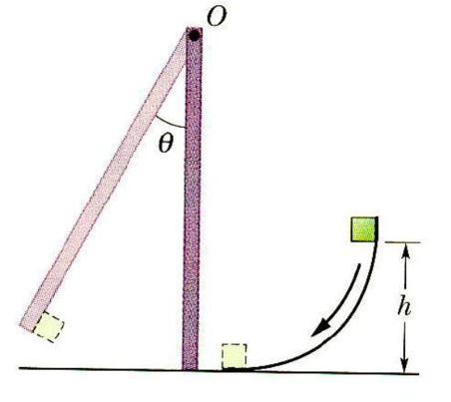

**Solution:**

The most difficult part is finding the angular velocity of the rod immediately after the collision. First, we point out that the horizontal *linear* momentum of the rod and the block is *not* conserved, because there is a horizontal force *exerted by the pivot* on the rod during the collision (can you see why?). The correct way to do the problem is using the conservation of the *angular* momentum. Due to the force from the pivot, we should choose $O$ as the coordinate origin to make the torque of the pivot to be zero. Then, since the gravity does not contribute to the torque neither, we obtain

$$lm_{1}v_{0}=\left(I_{1}+I_{2}\right)ω$$

Here

$$\frac{1}{2}m_{1}v_{0}^{2}=m_{1}gh, I_{1}=m_{1}l^{2}, I_{2}=\frac{1}{3}m_{2}l^{2}$$

After the collision, the mechanical energy is conserved. Therefore

$$\frac{1}{2}\left(I_{1}+I_{2}\right)ω^{2}=\left(m_{1}+m_{2}\right)gΔy_{CM}$$

(Don’t forget the $1/2$!) Here $Δy_{CM}$ is the height change of the CM of rod + block:

$$Δy_{CM}=\left(1-\cos{θ}\right)\frac{m_{1}l+m_{2}\left(\frac{l}{2}\right)}{m_{1}+m_{2}}$$

Finally, we obtain

$$θ=\arccos\left(1-\frac{6m_{1}^{2}h}{l\left(6m_{1}^{2}+5m_{1}m_{2}+m_{2}^{2}\right)}\right)=31.8°$$

1. I invented this name by myself.